# **Week 2**

In this session we are learning about data cleaning process , data modelling process and plot some visuals in power Bi.

We should plot some data visuals according to the data set.

After opening the data set in power query editor , make sure that these check boxes should be on.

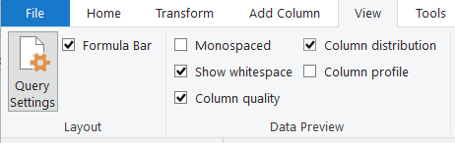

After doing this the data set would be look like this with visual graphs for each column.

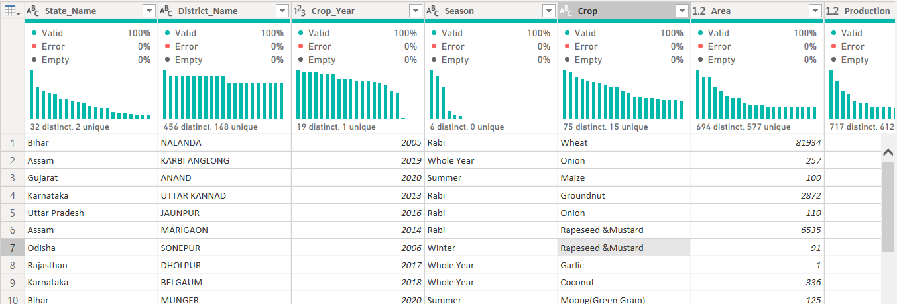

If we want to check the statistics of the column production we have to select the particular column name which we want to check the statistics and open view tab put a tick mark for the column profile. Then it appear like this.

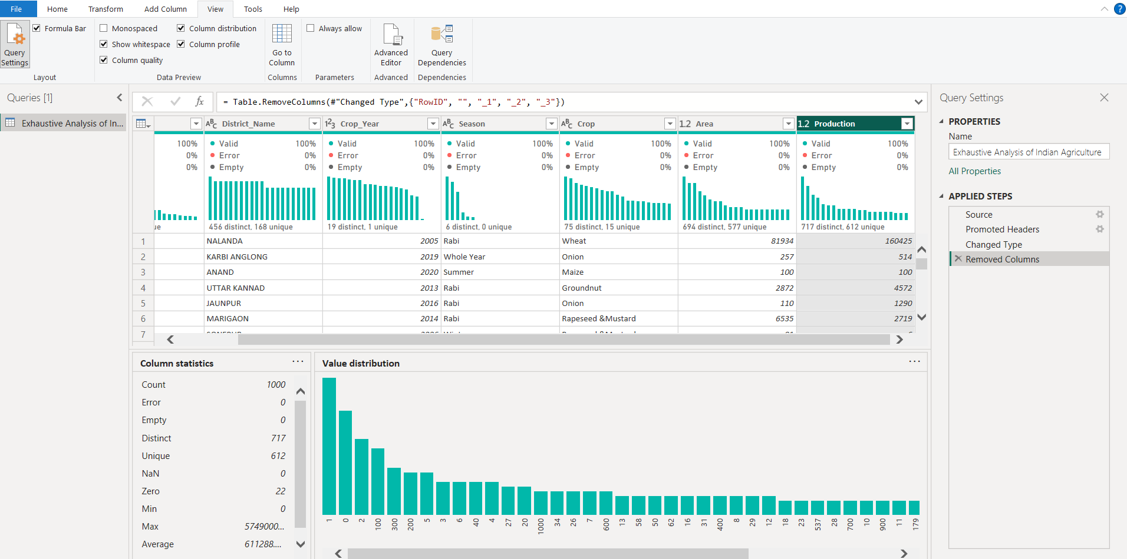

We can know all the statistical information about that particular column in the column profile.

We can change the name of the column or change the data type by right click on the column name to access some other options like this.

We select the column and select the group by and give the conditions which you want to group and conform it.

I am grouping by like this for a Season column.

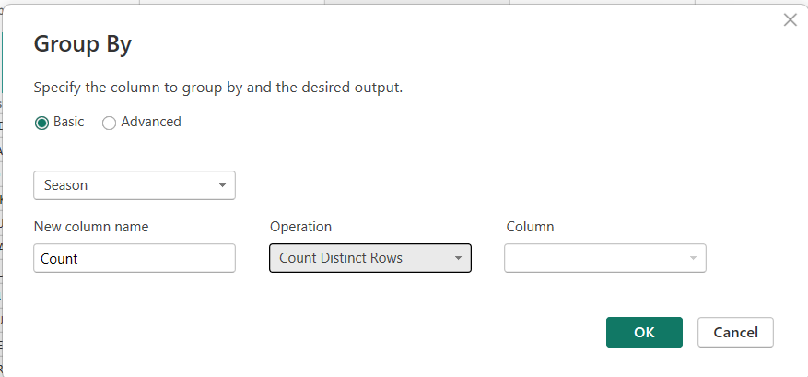

After clicking on ok it will look like this.

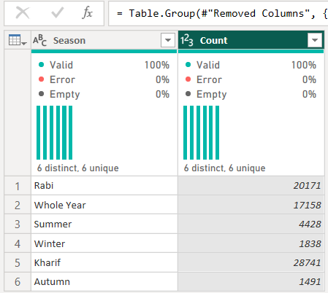

We can do all the operation for a data set or a column listed below in the Transform Tab



We can add new column in the data set with the help of Add Column tab

In the part of the data cleaning we can remove duplicates by selecting the following one.

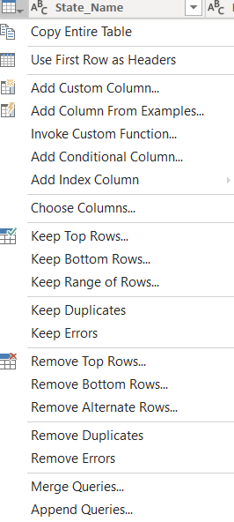

By clicking on the remove duplicates we can remove the duplicates.

After completing the transformation , we can know how to combine the queries. We can create the duplicate of our data set and remove the other columns.

For data modelling we do select the model view in the main window.

For visualizing the data , we move to the report view. We have to select the card from visualizations and , We just drag the column to the work space and then It will be look like this. And select what to visualize then it look like this.

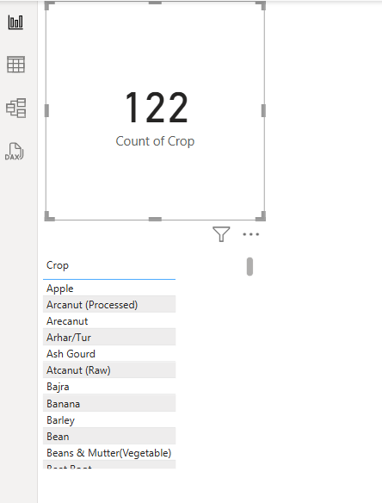

We can create a bar chart which contain one category value and the numerical value by selecting the bar chart from the visualizations and drag the columns to visualize the bar graph and it may look like this.

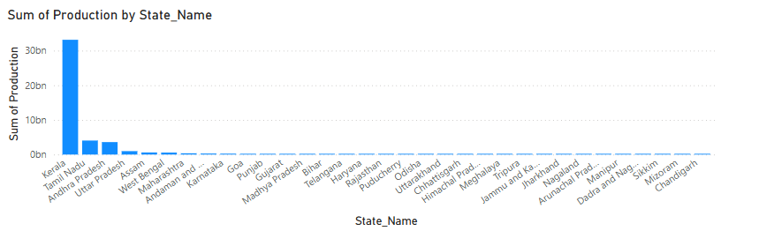

**PROBLEM STATEMENTS:**

1.Find the count of Crop Names

2.Find the highest production state.

3.Find the production according to crop Name.

4.Find the production according to Season.

5.Find Area with Tree Map.